Stratford Swimming Pool 2024 Season Opens
Saturday, June 1st, 2024 (tentative)

The pool is open daily to the public from 1-8 pm; weather permitting.
The pool offers many amenities such as:

Zero Depth Entry Wading Pool Concessions Private Pool Parties Swim Lessons

If you are interested in swim lessons for your child, you must prepay to confirm your child’s spot. Swim lesson registrations are enrolled on a first paid, first served basis; classes fill up fast! A form can be found on the back side of this sheet. Send the filled out form to City Hall by emailing it to cityofstratford@globalccs.net, or dropping it in the payment box outside City Hall, or mailing it to PO Box 218 Stratford, IA 50249-0218. For more pool information look on the City of Stratford’s website stratfordiowa.com, or stop in City Hall, or contact the City of Stratford at 515-838-2311.

Thank you for your interest in Stratford Municipal Swimming Pool 2024 Season.
We look forward to seeing you this summer!
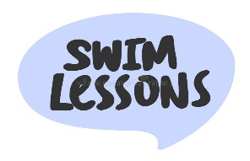

STRATFORD MUNICIPAL POOL
SWIM LESSON REGISTRATION FOR 2024 SWIM SEASON

Child’s Name (one child per form): _______________________________________________

Date: _____________ Phone: ______________________ Cell Phone: __________________

Email (required): _____________________________________________________________

Parent/Guardian Name: _________________________________________________________

Address: _____________________________________________________________________

Age of child: ______________ Check session you prefer 11:00 12:00

****Check the level you think your child is in****

Beginner’s _______ Level 1 _______ Level 2 _______ Level 3 _______ Level 4 ________

Swimming lessons will tentatively be held the week of June 17th through June 21st. The
sessions will be held at 11:00 am and 12:00 noon and will be 45 minutes long. Costs for
swimming lessons are $35.00 per child unless you have a Stratford Pool Family or Single
season pool pass. If you have a family or single pass then you get a $5.00 discount and the cost is then $30.00 per child. Swim Lesson spots are on a first paid, first served basis.
Send filled out registration form to City Hall.
You may email it to cityofstratford@globalccs.net, or drop it in the payment box
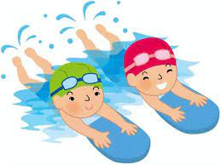
outside City Hall, or mail it to PO Box 218 Stratford, IA 50249-0218.
If have any questions please call City Hall at 515-838-2311.

